**Use Case Diagrams for Testing Center Scheduler**

Austin Borger, Robert Kinney, Joshua Ethridge, Luka Jurukovski

Version: 2015-09-10

**1. Overview**

The Testing Center Scheduler is a system that allows a student to schedule an appointment to take exams.  There are three human actors that interact with this system: Students, Instructors, and Administrators.  Students can only make or view appointments according to availability and within the scope of their course load.  Instructors can schedule exams for students to take, view all exams that they’ve scheduled thus far, cancel exams and view appointments made by their students, as well as availability for students to take their exams.  Administrators can perform any function within the system so long as it is logically sound - an admin can modify any student’s appointments, and can view and modify attributes of the system as well as attain the necessary statistics about the system’s performance.

**2. Use Case Diagrams**

For simplicity, the generalization between user and its specialized actors (student, instructor, and administrator), is not shown in the following diagrams. If one large diagram were to be constructed, this relationship would be shown – however, due to splitting up the diagrams into three separate pieces (one per actor), this relationship cannot be shown.

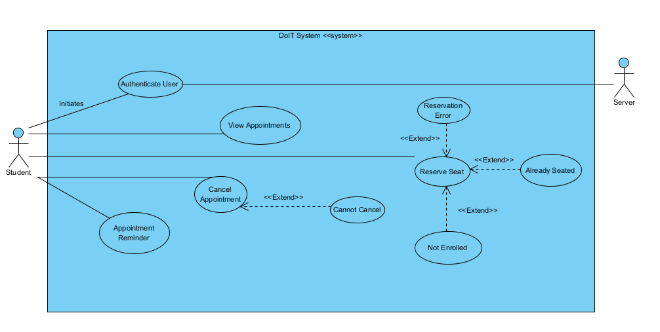

**Figure 2.1 – Student**

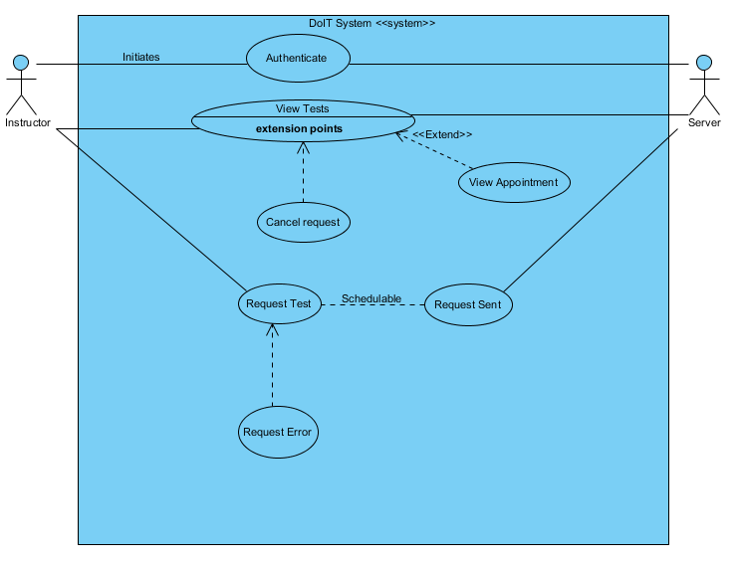

**Figure 2.2 – Instructor**

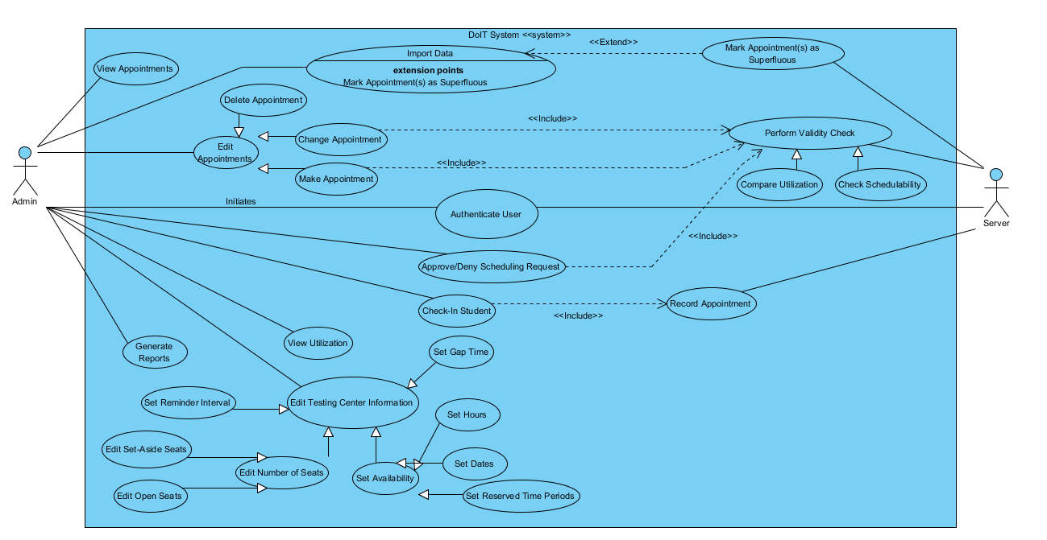

**Figure 2.3 – Administrator**

**3. Use Cases**

3.1 User

1. Authentication: The user logs into the system using his/her Solar ID and password. This tuple is checked against DoIT database.

3.1.1 Student

1. Reserve Seat: The student makes an appointment for one of his/her exams.
   1. Not Enrolled Error: The student is not enrolled in the course for the exam is being given or is not on the list of students to take an ad hoc exam.
   2. Already Seated: The student already has a seat for the exam.
   3. Reservation Error: There are no non-set-aside seats for the exam’s time period that do not conflict with the student’s other exams.
2. Cancel Appointment: The student can delete an appointment for an exam.
   1. Cannot Cancel: A student can only cancel an appointment prior to 24 hours before the appointment.
3. View Appointments
4. Appointment Reminder

3.1.2 Instructor

1. Request an Exam: The Instructor can make a request to hold an exam.
   1. Malformed request: The request is not a valid request variables are missing or improperly set.
   2. Unavailable date range: The date or dates listed are unavailable for testing.
2. See Requests and Statuses
3. Cancel Request
4. View appointment details
5. View details about exam
6. Student’s appointment, assigned seat and if the student showed up

3.1.3 Admin

1. Edit testing center information. This includes the ability to:
   1. Edit the number of seats.
   2. Edit the number of set-aside seats.
   3. Edit the hours of the testing center, including dates open.
   4. Edit the dates and times the testing center is reserved for non-Stony Brook exams.
   5. Edit the gap time.
   6. Set the reminder interval.
2. Import data
   1. Superfluous appointments: When there is data that does not match up with the appointment schedule and the class roster – that is, a student is registered for an exam for a course that they are not registered for – the student’s appointment is removed and an email is sent to the student, instructor, and administrator.
3. Display the utilization of the testing center
4. Approve or deny exam scheduling
5. Make an appointment on behalf of a student
6. View appointments
7. Cancel or modify appointments
8. Check-in students
9. Generate reports. Reports include:
   1. The number of student appointments on a given day.
   2. The number of student appointments on a given week, along with the course identifiers that correspond with the associated exams.
   3. The courses that are being used in the testing center for a given term.
   4. The number of student appointments in each term across a range of terms.

**4. Contributions**

Luka Jurukovski was responsible for writing the use case descriptions for the instructor actor, as well as constructing the use case diagram for said actor.  Austin Borger was responsible for the admin use case diagram, as well as the overview section of this document.  Robert Kinney was responsible for both the student use case diagram and description.  Joshua Ethridge was responsible for collaborating with the formation of the admin use case diagram, as well as writing the use case description for the admin.